Find the solution to each system of equations by finding the intersection of two graphs.
- $\left\{\begin{matrix}y=-\frac{5}{3}x+3 \\ y=\frac{1}{3}x-3\end{matrix}\right.$ | - $\left\{\begin{matrix}y=-\frac{1}{2}x-1 \\ y=\frac{1}{4}x-4\end{matrix}\right.$
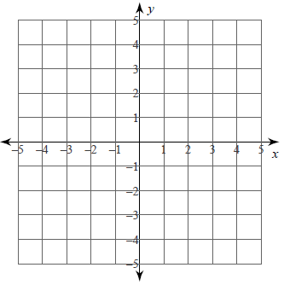

- $\left\{\begin{matrix}y=3x-4 \\ y=-\frac{1}{2}x+3\end{matrix}\right.$ | - $\left\{\begin{matrix}y=-\frac{1}{2}x-2 \\ y=-\frac{3}{2}x+2\end{matrix}\right.$

- $\left\{\begin{matrix}y=\frac{1}{3}x-3 \\ y=-x+1\end{matrix}\right.$ | - $\left\{\begin{matrix}y=-\frac{2}{3}x-2 \\ y=-\frac{8}{3}x+4\end{matrix}\right.$

- $\left\{\begin{matrix}x-3y=-9 \\ 2x-y=2\end{matrix}\right.$ | - $\left\{\begin{aligned}2x-4y=4 \\ 3x-4y=16\end{aligned}\right.$

