8.F.A.1&3 Graphing Slope-Intercept Equations
Graph the line in slope-intercept form
- $y=3x+2$  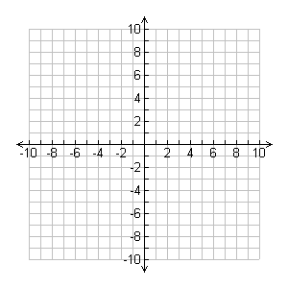 | - $y=5x-8$
- $y=2x-7$ | - $y=-2x+5$

- $y=x-1$ | - $y=x+4$
- $y=\frac{2}{3}x+2$ | - $y=\frac{1}{2}x+3$

