Graphing Systems Review
Graph each system of equations to find the solution

- $\left\{\begin{matrix}y=2x+6 \\ y=-\frac{1}{2}x+1\end{matrix}\right.$  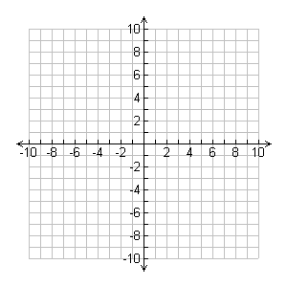 | - $\left\{\begin{matrix}4x-3y=15 \\ y=\frac{4}{3}x+6\end{matrix}\right.$
- $\left\{\begin{matrix}y=-\frac{1}{2}x+3 \\ 2x+4y=12\end{matrix}\right.$ | - $\left\{\begin{matrix}4x+8y=-24 \\ -4x-2y=-12\end{matrix}\right.$

